- Copyright for test papers and marking guides remains with West Australian Test Papers.
- The papers may only be reproduced within the purchasing school according to the advertised conditions of sale.
- Test papers must be withdrawn after use and stored securely in the school until Friday June 14

HUMAN BIOLOGY

Unit 3

2019

Name: _______________________________________________________

Teacher: ___________________________________________________

TIME ALLOWED FOR THIS PAPER

Reading time before commencing work: Ten minutes
Working time for the paper: Three Hours

MATERIALS REQUIRED/RECOMMENDED FOR THIS PAPER
To be provided by the supervisor:
- This Question/Answer Booklet
- Multiple Choice Answer Sheet

To be provided by the candidate:
- Standard items: Pens, pencils, eraser or correction fluid, ruler, highlighter, ruler.
- Special items: Calculators satisfying the conditions set by the Schools
Curriculum and standards authority for this subject.

IMPORTANT NOTE TO CANDIDATES

- No other items may be taken into the examination room. It is your responsibility to ensure that you do not have any unauthorised notes or other items of a non-personal nature in the examination room. If you have any unauthorised material with you, hand it to the supervisor before reading any further.

Structure of this paper

Section | Suggested working time | Number of questions available | Number of questions to be attempted | Marks | Percentage
SECTION ONE:  Multiple-choice | 50 minutes | 30 | All | 30 | 30
SECTION TWO:  Short answers | 90 minutes | 6 | All | 100 | 50
SECTION THREE:  Extended answers | 40 minutes | 3 | 2 | 40 | 20
 |  |  | Total marks | 170 | 100

Instructions to candidates
1. The rules for the conduct of Western Australian external examinations are detailed in the Year 12 Information Handbook 2019. Sitting this examination implies that you agree to abide by these rules.
2. Answer the questions according to the following instructions.

Section One: Answer all questions on the separate Multiple-choice Answer Sheet provided. For each question shade the box to indicate your answer. Use only a blue or black pen to shade the boxes. If you make a mistake, place a cross through that square, do not erase or use correction fluid, and shade your new answer. Marks will not be deducted for incorrect answers. No marks will be given if more than one answer is completed for any question.

Sections Two and Three: Write your answers in this Question/Answer Booklet.
3. You must be careful to confine your responses to the specific questions asked and to follow any instructions that are specific to a particular question.
4. Spare pages are included at the end of this booklet. They can be used for planning your responses and/or as additional space if required to continue an answer.
- Planning: If you use the spare pages for planning, indicate this clearly at the top of the page.
- Continuing an answer: If you need to use the space to continue an answer, indicate in the original answer space where the answer is continued, i.e. give the page number. Fill in the number of the question(s) that you are continuing to answer at the top of the page.

Section One: Multiple-choice 30% (30 Marks)
This section has 30 questions. Answer all questions on the separate Multiple-choice Answer Sheet provided. For each question shade the box to indicate your answer. Use only a blue or black pen to shade the boxes. If you make a mistake, place a cross through that square, do not erase or use correction fluid, and shade your new answer. Marks will not be deducted for incorrect answers. No marks will be given if more than one answer is completed for any question.
Suggested working time: 50 minutes.

- The organ(s) responsible for the control of sleep patterns and waking is thought to be the

- hypothalamus and medulla oblongata.
- medulla oblongata.
- pineal gland and hypothalamus.
- parathyroid gland.

- The thymus gland is thought to be responsible for

- influencing the maturation of T cells.
- stimulating the growth of ovarian follicles.
- promoting milk production.
- the contraction of smooth muscle in the uterus and mammary glands.

- A scientific experiment must have a control. The control is needed to

- ensure only one variable is tested at a time.
- indicate what effect the independent variable has had on the results.
- decrease the number of outliers in the results.
- indicate if any similarities are due to the controlled variables.
Use the diagram below to answer Question 4.
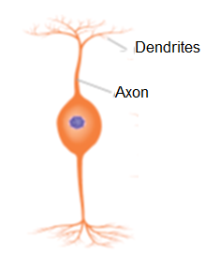
- Which of the following correctly labels the structural type, impulse direction and location of the neuron shown above.

 | Structural Type | Impulse direction | Location
(a) | Bipolar | From receptor cells to other neurons | Eye and ear
(b) | Unipolar | From spinal cord to motor neurons | Spinal cord
(c) | Motor | Receives impulses from spinal cord | Skeletal muscles
(d) | Multipolar | Receive from interneurons | Organs

- The difference between white and grey matter within the brain is that:

- the white matter is found on the outside of the brain whilst the grey matter is inside.
- the grey matter contains the unmyelinated nerve fibres and the white matter contains the cell bodies.
- the white matter contains the dendrites of neurons, the grey matter contains the nerve fibres.
- the grey matter contains the cell bodies of neurons, the white matter contains the myelinated nerve fibres.

- Many nerve fibres consist of an axon, covered with a myelin sheath and a neurilemma. The neurilemma is

- responsible for the repair of injured fibres.
- produced by Schwann cells located along the dendrite.
- continuous all the way along the cell body.
- responsible for the colour of the grey matter in the central nervous system.

- The process that involves the decomposition of hormones is called

- negative feedback.
- enzyme amplification.
- hormone clearance.
- hormone amplification.

Refer to the following diagram, showing the processes involved in breast feeding, to answer the next THREE questions.
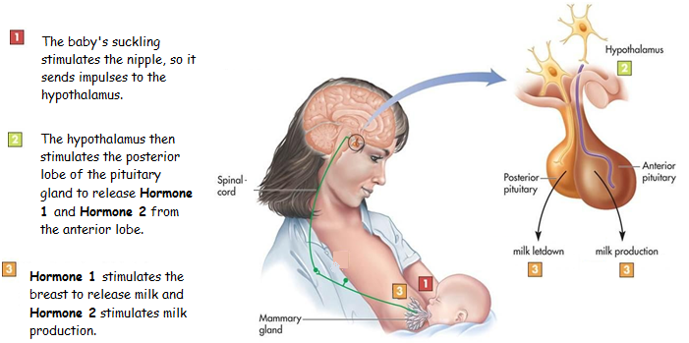
- In this stimulus-response and feedback process, the modulator would be the

- nipple and areola.
- hypothalamus
- pituitary gland.
- oxytocin.

- The type of feedback involved in this process would be

- negative feedback, as the response negates the stimulus.
- positive feedback, as the response negates the stimulus.
- negative feedback, as the response intensifies the stimulus.
- positive feedback, as the response intensifies the stimulus.

- Hormone 2 differs to Hormone 1 because Hormone 2 is

- produced in and released from the anterior lobe of the pituitary.
- produced in the hypothalamus and sent to the anterior lobe of the pituitary via nerve fibres.
- produced in the hypothalamus and sent to the anterior lobe of the pituitary via blood vessels.
- secreted from the hypothalamus and sent to the anterior lobe of the pituitary via blood vessels in the infundibulum.

- Which of the following statements about the visceral sensory neurons are correct?

- They relay impulses from the central nervous system to the skin and muscles.
- They transmit impulses from the internal organs to the central nervous system.
- They relay impulses from the skin and muscle to the central nervous system.
- They transmit impulses from the central nervous system to involuntary muscles.

- The autonomic nervous system is regulated by a group of nerve cells in the

- medulla oblongata and cerebral cortex.
- hypothalamus and cerebral cortex.
- hypothalamus and thalamus.
- medulla oblongata, hypothalamus and cerebral cortex.

- Which of the following cell organelles are stimulated to release a neurotransmitter from an axon terminal?

- Vesicles.
- Lysosomes.
- Centrioles.
- Receptor protein.

- Which of the following statements about the autonomic division of the peripheral nervous system is correct?

- This system is under voluntary control and can inhibit or excite the effector.
- It is made up of two nerve fibres that may excite or inhibit the effector.
- It consist of sensory neurons that respond to external environmental changes.
- The autonomic division releases acetylcholine and is responsible for maintaining homeostasis.

- The nervous and endocrine systems differ in how they control body functions. The nervous system differs from the endocrine system as the nervous system

- transfers neurotransmitters through the bloodstream.
- provides positive feedback to stimuli.
- provides impulses that travel to specific parts of the body and stimulate one effector.
- provides impulses that travel to all parts of the body and stimulate one effector.

- The function of the ________ is to enable the two sides of the cerebrum to communicate with each other.

- Corpus callosum
- Medulla oblongata
- Basal ganglia
- Cerebellum

- Bacteria

- contain DNA or RNA, but not both.
- contain organelles surrounded by a protein coat.
- are considered to be non-living organisms.
- possess a cell membrane surrounded by a cell wall.

- Bacteriostatic antibiotics are effective at killing bacterial infections because they

- stop bacteria from reproducing.
- prevent the bacteria from growing.
- disrupt cellular respiration.
- disrupt the action of essential enzymes.

- Which of the following types of immunity is responsible for vaccinating a large proportion of the population, making it difficult for an infectious disease to spread?

- Passive immunity
- Herd immunity
- Active immunity
- Living attenuated

- Which of the following best describes a non-specific external defence that stops pathogens from entering the body.

 | Type of defence | Strategy applied
(a) | Stomach acid | Increases the pH of the environment killing any pathogens.
(b) | Cilia | Tiny hair-like projections covered in mucus that capture pathogens in the respiratory system.
(c) | Cerumen | An oily substance released onto the skin to trap pathogens.
(d) | Lysozyme | An alkaline substance that kills bacteria, found in tears and sweat.

- When the hormone glucagon reaches a target cell, it attaches to a receptor protein. This causes a secondary messenger to be released which activates a specific enzyme in the cell.

Glucagon is a

- water soluble steroid hormone.
- lipid soluble steroid hormone.
- water soluble protein hormone.
- lipid soluble protein hormone.

- As a result of a brain injury, an individual now has difficulty breathing and needs to take conscious control periodically to maintain their oxygen levels. The part of their brain most likely damaged would be their

- hypothalamus.
- cerebral cortex.
- cerebellum.
- medulla oblongata.

Refer to the picture below to answer the next question.
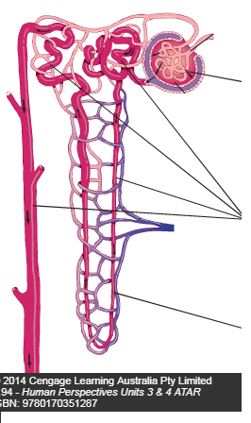
3
2
1
- Which of the following correctly identifies the processes occurring to produce urine?

 | 1 | 2 | 3
(a) | Secretion | Filtration | Reabsorption
(b) | Reabsorption | Secretion | Filtration
(c) | Filtration | Reabsorption | Secretion
(d) | Filtration | Reabsorption | Urination

- Natural active immunity can be obtained by:

- antibodies entering the blood stream across the placenta.
- antigens entering the blood stream via air droplets.
- providing antibodies through an injection.
- antigens entering the bloodstream via a vaccine.

- Which of the following statements correctly presents a difference between antibiotics and vaccines?

- Antibiotics do not provide immunity, while vaccines can provide active artificial immunity.
- Antibiotics provide long term immunity through memory cells, while vaccines provide short term immunity.
- Antibiotics are a type of active artificial immunity, while vaccines are passive artificial immunity.
- Antibiotics are often injected into the bloodstream and vaccines are ingested as a pill.

- Which of the following symptoms would a person suffering from hyperthyroidism be likely to show?

- weight loss
- increased body surface temperature
- intolerance to cold
- weight gain
The following information is needed to answer the next FOUR questions.
In 2002, Dr Karl Kruszelnicki conducted a survey through the internet to find out what type of personal traits resulted in the greatest amount of belly button lint. The age groups that provided the most meaningful statistics can be seen below.

Age range | 16 – 20 | 21 – 25 | 26 - 30 | 31 – 35 | 36 - 40 | 41 - 45 | 46 – 50 | 51 - 55
Belly button lint presence | 768 | 732 | 700 | 692 | 486 | 440 | 145 | 62

- The percentage of 26 – 30 year olds that represented the total sample frame was

- 33.2%.
- 5.75%.
- 20%.
- 17.4%.

- The median number of people who responded to the survey who get belly button lint is

- 503
- 692
- 589
- 486

- The percentage change in the presence of belly button lint from the 16 – 20 to 51 – 55 age group is a

- 10.1% increase.
- 91.9% decrease.
- 10.1% increase.
- 91.9% increase.

- The most correct term used to describe the data obtained from this survey is

- quantitative data.
- reliable data.
- qualitative data.
- valid data.

Section Two: Short answer 50% (100 Marks)
This section has six (6) questions. Answer all questions. Write your answers in the spaces provided.
Spare pages are included at the end of this booklet. They can be used for planning your responses and/or as additional space if required to continue an answer.
  - Planning: If you use the spare pages for planning, indicate this clearly at the top of the page.
  - Continuing an answer: If you need to use the space to continue an answer, indicate in the original answer space where the answer is continued, i.e. give the page number. Fill in the number of the question(s) that you are continuing to answer at the top of the page.

Suggested working time: 90 minutes.
Question 31 (19 marks)
Pepper spray is a chemical substance dispersed from an aerosol can to cause temporary blindness and physical discomfort in people or animals. It is used by police, so they can easily detain aggressive suspects. Capsaicin is the chemical responsible for causing the irritations the victim experiences and the two homeostatic mechanisms described below.
Capsaicin is capable of binding to the active site of capsaicin (TRPV1) receptor proteins located within the cell membrane of C nerve fibres, which are located within the skin and muscles. These receptors are normally stimulated by surface temperatures greater than 43°C. When these protein channels are opened, a gradual and slow burning sensation can be felt by the subject, causing them to break out into a heavy sweat. Furthermore, when stimulated by capsaicin, the C nerve fibres release a variety of paracrines called neuropeptides. These chemicals bind to and stimulate mast cells, in response to the capsaicin.
- State which division of the nervous system the C nerve fibres are placed in and explain why. (3 marks)

Afferent division (1)
C nerve fibres are sensory neurons located under the skin/within muscles (1) sending messages to the central nervous system (1).

- Using the space provided below, draw and label a diagram of a unipolar C neuron.
(2 marks)
Correctly drawn unipolar neuron – 1 mark Correctly labelled parts – 1 mark
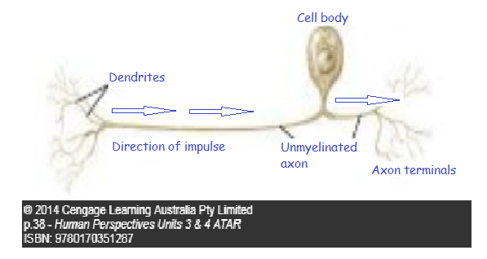
- Using the diagram drawn for Question 31 (b), draw and label an arrow that shows the direction the impulse would travel through the C neuron. (1 mark)
See diagram above.

- A specific structural feature of the C neuron axon is absent and gives rise to its ability to provide a slow burning sensation. State what this missing feature is and describe why it provides a slow burning sensation, in contrast to a neuron that provides a rapid pain message. (4 marks)

The unipolar C fibre has an unmyelinated axon / has an axon that is missing myelin sheath (1), which results in slow conduction (1), as the action potential travels along the whole length of the membrane/axon (1), rather than jumping from one Node of Ranvier to the next (1) on a myelinated axon.

- When someone is subjected to pepper spray, they usually react by producing excessive tears and mucus, become red and hot in the face and have swelling around the eyes. They also experience a slow burning sensation, which results in heavy sweating.
  - Name and describe the process that would lead to the subject producing excessive mucus, becoming red and hot in the face and have swelling around the eyes. (5 marks)
Inflammatory response (1 mark)
Mast cells are stimulated to release histamines (and heparin) (1)
Histamines increase mucus/blood flow to effected area (1), causing heat in the face (1) and the escape of the fluid from the blood causes swelling (1)

  - Describe two (2) responses that would occur to cause the subject to sweat heavily and become red in the face and explain how these responses would lower their body temperature. (4 marks)
Vasodilation in the skin (1)
Redness due to blood under skin/at surface (1)
Sweat glands release sweat, (1)
which evaporates and removes latent heat. (1)

Question 32 (19 marks)
Food allergy occurs in around 5-10% of children in Australia. Some food allergies can be severe, resulting in potentially life-threatening allergic reactions. Oral immunotherapy (OIT) is a possible remedy for food allergies that involves administering gradually increasing amounts of food allergen under medical supervision, in an attempt to develop desensitisation of the allergen.
A clinical trial was conducted to see if a group of 1-6 year old subjects, allergic to peanuts, could be desensitised against peanuts. The normal range of IgE antibodies is between 150 – 300 Ul/mL. They were separated into two groups and given 67mg of a specific type of flour over 60 months, where neither group knew which flour type they were ingesting. The average results for the last 8 months can be seen below.

Month flour taken | Average IgE levels in Ul/mL in blood.
 | Subjects taking Peanut flour | Subjects taking the Oat flour
52 | 300 | 291
53 | 298 | 290
54 | 294 | 287
55 | 291 | 286
56 | 288 | 288
57 | 283 | 287
58 | 275 | 286
59 | 268 | 289
60 | 262 | 290

- Write a suitable hypothesis for this experiment. (1 mark)

Statement must include the independent and dependent variable.
For example – If a group of children allergic to peanuts are given increasing amounts of peanut flour over a 60 month period, they will produce less IgE antibodies.

- Identify the independent and dependent variable for this experiment. (2 marks)

Independent – The type of flour being ingested, peanut vs oat.
Dependent – The average amount of IgE antibodies

- Briefly describe two ethical principles that would need to be addressed in this clinical trial. (2 marks)
Any two of the following to a maximum of 2 marks.
- Voluntary participation – the subjects must be willing/agree to taking part (1)
- Informed consent – The participate must be fully informed about the procedure of the experiment and the procedure that will take place (1)
- Risk of harm – there should be no risk of physical or psychological harm (1)
- Confidentiality – The identities of the participants is only revealed to research staff (1)

- Plot a graph of the data contained in the table. (A spare grid is provided on page 32) (5 marks)
Graph; mark allocation 1 mark for each of the following dot points
- Title – including both independent and dependent variables
- Correctly labelled x axis (months) and axis divided evenly
- Correctly labelled y axis (dependent variable with unit) and axis evenly divided
- Accurately positioned points and adjacent points joined by straight lines
- Use of a key/legend to identify each line.
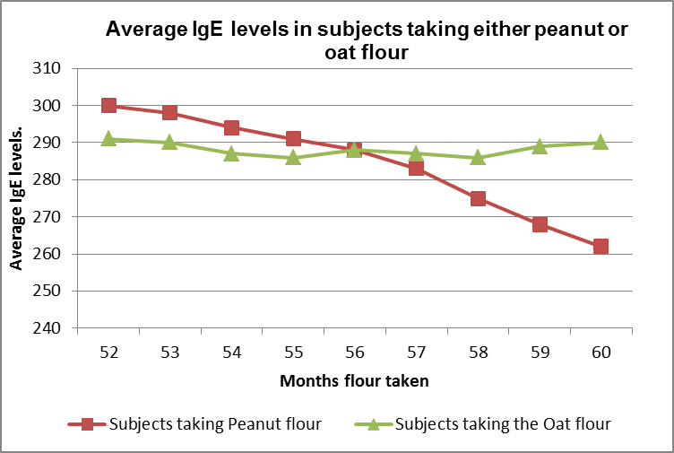

- What conclusion can be drawn from the results? (2 marks)
The gradual introduction of peanut flour decreases the average amount of IgE antibodies produced (1)
The gradual introduction of oat flour has little/no apparent effect on the average amount of IgE antibodies (1)
- Using a labelled diagram (drawn in box 1), explain (in box 2) why the peanut IgE antibodies can only combine with the peanut antigen. (5 marks)

Box 1. (2 marks)  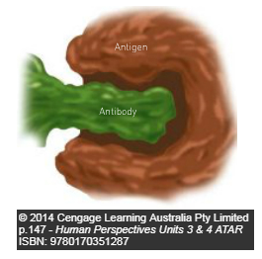  Correctly drawn diagram showing lock and key arrangement (1)  Correctly labeled antigen and antibody (1) | Box 2. (3 marks)  MUST HAVE the following two points for one mark each.  - Antigen molecules have specific active sites (1)  - Antibodies are specifically made to combine with the active site of the antigen (1)  Either of the following point for a maximum of 1 mark.  - The active site on the antigen and the active part of the antibody fit together like a key into a lock (1)  - The antibody produced for the antigen, can combine to form an antigen-antibody complex (1)

- Describe the sequential events that occur that result in the development of the antigen-antibody complex . (4 marks)

- Antigen presenting cell/macrophage displays antigen on its surface (1)
- B cells/lymphocytes are sensitised, enlarge and divide (1) to become clone cells
- Clone cells that become plasma cells produce antibodies (1)
- Antibodies attach to the active site of the antigen, to form antigen-antibody
complex (1)

Question 33 (14 marks)
Use the diagram below to answer the following questions.

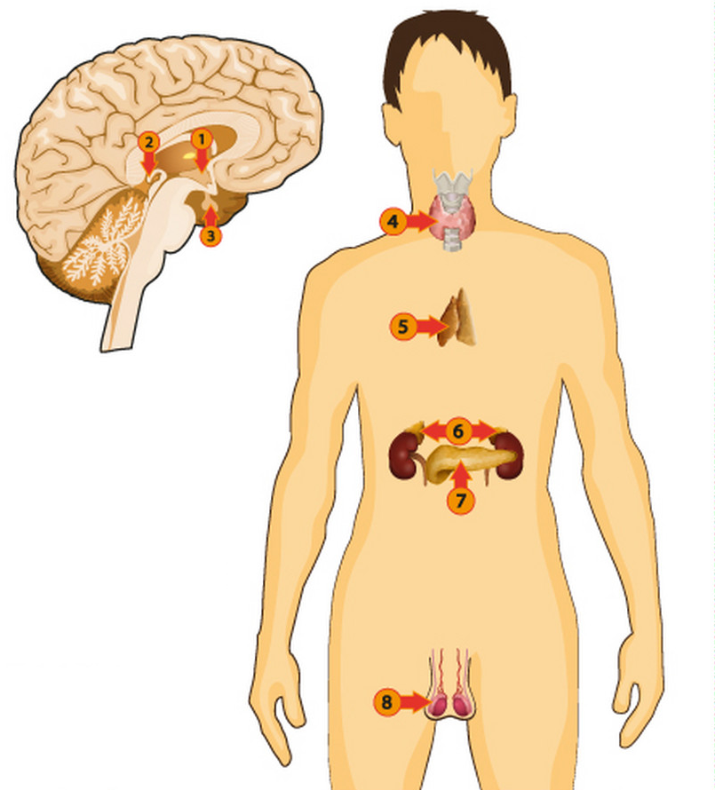
- Provide the number of the endocrine gland in the diagram above that secretes the hormone
i) ADH. (1 mark)
3 (1)
ii) aldosterone. (1 mark)
6 (1)
iii) thymosins. (1 mark)
5 (1)

- ADH and aldosterone both play an important role in the regulation of body fluid composition. Explain how these hormones can increase the water concentration of the blood plasma. (6 marks)
ADH
- Targets the kidney tubules / distal convoluted tubule and collecting duct (1),
- increasing the permeability of the walls, (1)
- allowing water to re-enter the blood capillaries. (1)
Aldosterone
- Targets the kidney tubules / distal convoluted tubule and loop of Henle, (1) which
- increases the amount of sodium reabsorbed into the blood capillaries, (1)
- where water is also reabsorbed along with the sodium, into the blood stream (1)

- i) Using the space provided, draw and label a picture to show the different locations of blood plasma, intercellular fluid and intracellular fluid. (2 marks)
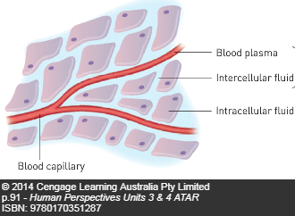
Clear and appropriately drawn diagram (1)
All 3 fluids correctly labelled (1)
ii) List the fluids in order that the water molecules would travel through if the osmotic pressure of the blood plasma was low in order. (1 mark)
Blood plasma, intercellular, intracellular (1)
iii) If an individual has a very low osmotic pressure within their blood plasma, they may experience lightheadedness, vomiting and they could collapse. State what the name of this condition is and explain what the person could consciously do to correct their osmotic pressure. (2 marks)
- Water intoxication or water poisoning (1)
- Consume water with dissolved salt/sports drink with electrolytes (1)
Question 34 (17 marks)
Refer to the diagram below to answer the following questions.
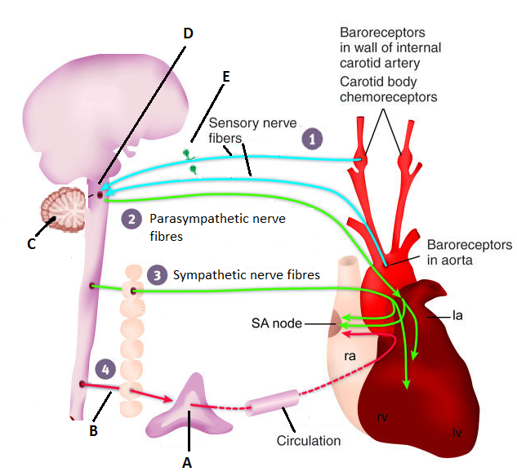

- State the function of the carotid and aortic bodies. (1 mark)
Detect an increase in carbon dioxide/decrease in blood pH (1)
- Name the endocrine gland labelled “A” in the diagram. (1 mark)
Adrenal medulla (1)
- Assuming the carotid and aortic bodies have been stimulated, complete the following table to identify similarities and differences between those parts labelled “A” and “B” in the diagram. (4 marks)

1 mark for each correct column. ½ marks cannot be awarded.

Part label | Nature of chemical message | Name of chemical released to transfer message | Effect chemical(s) has/have on target cells/organ | Time taken to respond.
A | Hormone | Noradrenaline | Noradrenaline increases heart rate and force/stroke volume | Slower/seconds
B | Neurotransmitter (1) | Noradrenaline (1) | Adrenal medulla releases (more) noradrenaline/adrenaline (1) | Rapid/milliseconds (1)

- Complete the following table. (4 marks)

Brain Part label | Brain part name | Brain part function
C | Cerebellum (1) | Control over posture or  Control of balance or  Control of fine motor skills. (1)
D | Medulla Oblongata (1) | Cardiac centre or  Respiratory centre or  Vasomotor centre. (1)

- Identify the nerve fibre part shown as “E” in the diagram and state which parts of the nerve cell would be found within “Part E”. (2 marks)

- Dorsal root ganglion (1)
- Cell bodies of the sensory neurons. (1)

- The automatic response being shown in the diagram above is coordinated by the spinal cord and occurs as a result of a change in the internal environment. State the name of the type of response being shown in the diagram and describe the four properties these responses have in common. (5 marks)

- Spinal reflex/reflex (1)
- Stimulus – is required to trigger the reflex/reflex is not spontaneous.
- Involuntary – occurs without conscious thought.
- Rapid – only a small number of neurons involved.
- Stereotyped – occurs in the same way each time.

Question 35 (11 marks)
Refer to the diagram below to answer Question 35.
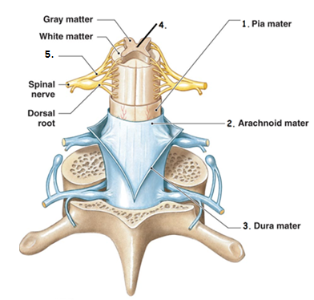
- The parts labelled 1,2 and 3 in the diagram work together to protect the spinal cord. State the collective name used to identify these parts and describe three functions these layers carry out.
(4 marks)
MUST HAVE
- Meninges (1)

Any of the following to a maximum of three marks.
- They (the outer layer) provide a strong and thick surface that provides protection against contact forces. (1)
- They (the middle and inner layer) provide (impermeable) surfaces that hold cerebrospinal fluid in place, (1)
- which cushions the central nervous system (1)

- Identify the fluid within part 4 of the diagram and describe three functions of this fluid.
(4 marks)
MUST HAVE for one mark
- Cerebrospinal fluid (1)

Any of the following for 1 mark each, to a maximum of 3 marks.
- Protection – acts as a shock absorber/cushions any blows the CNS may sustain (1)
- Support - the brain is suspended inside the cranium and floats in the fluid. (1)
- Transport of nutrients/wastes – While circulating, the fluid delivers nutrients and removes wastes to/from the cells of the brain and spinal cord (1)

- Name the type of neurons that would be found within part 5 of the diagram and describe the roles played by these neurons. (3 marks)

- Motor neurons (1)
- Takes impulses from the CNS to skeletal muscles (1)
- Takes impulses from the CNS to involuntary muscles/glands (1)

Question 36 (18 marks)
Amoebic meningitis is a serious disease that leads to inflammation of the brain and can cause death. It’s caused by the Naegleria fowleri amoeba, pictured below.
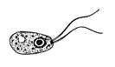
The Naegleria fowleri amoeba grows in warm, untreated water and flourishes in temperatures between 25°C and 40°C. It can be found in stagnant water such as lakes, neglected swimming pools and water hoses.
Amoebic meningitis infection happens if water containing the Naegleria fowleri amoeba is forced up the nose, via jumping or diving into the water. The amoeba can then make their way to the brain by attaching to and migrating along the olfactory sensory neurons, where it then causes inflammation and destroys brain tissue. You cannot get infected from swallowing contaminated water.
Some of the symptoms of a Naegleria fowleri amoeba infection include fever, vomiting, sore throat, stiff neck and seizures.
- Looking at the diagram of the amoeba shown above, identify two reasons why it cannot be considered a virus. (2 marks)

- Possesses a nucleus, viruses do not have a nucleus (1)

- Possesses flagella, which viruses do not have. (1)

- Using the diagram below, circle the area of the brain where the Naegleria fowleri amoeba infection would initially begin and state why it would start there. (3 marks)

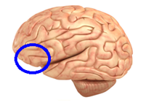(1)

The Naegleria fowleri amoeba would initially infect the primary olfactory (smell)
area (1) as they made their way there via olfactory sensory neurons (1).

- Identify a protective reflex someone with a Naegleria fowleri amoeba infection would experience and explain how this reflex would occur. (3 marks)
- Vomiting (1)
- The contraction of the muscles of the abdomen and the diaphragm (1) causes the contents of the stomach to be expelled. (1).
- State why an infection cannot occur if someone swallows water with the amoeba in it.
(1 mark)
- Stomach acids destroy the amoeba (1)
- Explain how the amoeba would stimulate the body to develop a fever.
(5 marks)
- Amoeba’s presence stimulates inflammatory response (1)
- White blood cells that accumulate in the area, release pyrogens (1)
- Pyrogens are detected by hypothalamus (1)
- Hypothalamus increases the body core temperature (1)
- The hypothalamus causes the body to carry out actions that generate/retain body heat (1)

- Describe three reasons why a fever would normally reduce the number of pathogens within a body and state why the Naegleria fowleri amoeba would be resistant to a fever.
(4 marks)
- High body temperatures inhibit the growth of pathogens (1)
- High body temperatures can denature the proteins/enzymes that allow the pathogen to live (1), subsequently causing the pathogen to die.
- High body temperature speeds up the rate of metabolism, allowing body cells to repair faster (1)

- Naegleria fowleri amoeba resistant as it lives/survives in water temperatures at 40°C (1).

Section Three: Extended answer 20% (40 Marks)
This section contains three (3) questions. You must answer two (2) questions. Make sure you clearly indicate which question you are answering and write your answers in the space provided.
Spare pages are included at the end of this booklet. They can be used for planning your responses and/or as additional space if required to continue an answer.
- Planning: If you use the spare pages for planning, indicate this clearly at the top of the page.
  - Continuing an answer: If you need to use more space to continue an answer, indicate in the original answer space where the answer is continued, i.e. give the page number. Write the number of the question(s) that you are continuing to answer at the top of the additional space page.

Responses could include clearly labelled diagrams with explanatory notes; lists of points with linking sentences; clearly labelled tables and graphs; and annotated flow diagrams with introductory notes.
Suggested working time: 40 minutes.
______________________________________________________________________________
Question 37 (20 marks)
All of the cells of the body require a continuous supply of glucose and oxygen for cellular respiration. The concentration of oxygen, carbon dioxide and hydrogen ions in the blood plasma all have some effect on the regulation of breathing.
- Explain the relationship between carbon dioxide and hydrogen ions within the blood plasma and how hydrogen ions affect an individual’s breathing rate. (5 marks)

- As carbon dioxide is dissolved in water, within the blood plasma, it forms carbonic acid (1), which then dissociates
- to form hydrogen and bicarbonate ions (1) in solution.
- Hydrogen ions stimulate peripheral chemoreceptors/aortic and carotid bodies (1) which then
- send impulses to the respiratory centre/inspiratory centre/medulla oblongata (1),
- which stimulates diaphragm and intercostal muscles to contract more regularly(1),
resulting in an increase in the breathing rate.

- The muscles responsible for increasing an individual’s breathing rate require stimulation from nerve impulses. Explain how an action potential is transmitted along a myelinated nerve fibre.
(10 marks)
One mark each for any 10 of the following points:
- The resting neuron has a positive charge on the outside of the membrane and negative charge on the inside/ potential difference of -70mV.
- There is a high concentration of positive sodium ions on the outside and a high concentration of positive potassium ions on the inside.
- There is a greater concentration of negatively charged protein and nucleic acid molecules in the cytoplasm than positively charged K+,
- making the inside negatively charged.
- A stimulus (greater than the neuron’s threshold value) causes the sodium ion channels to open
- The inward movement of the positively charged sodium ions reverses the charges either side of the membrane.
- The cell has become depolarised, the charge on the inside is positive and the charge on the outside is negative.
- After the inside of the cell becomes flooded with sodium ions, the gated ion channels on the inside of the membrane open to allow the potassium ions to move to the outside of the membrane.
- As soon as the potassium ions are released, the sodium gated channels close.
- The neuron/membrane is now repolarised.
- The action potential has now passed and adjacent gated sodium ion channels are stimulated to open, so the impulse is passed along the axon.
- When an impulse travels down an axon covered by a myelin sheath, the impulse must move between the uninsulated gaps called the nodes of Ranvier that exist between each Schwann cell.
- The impulses move in one direction along the neuron because the sodium channels cannot immediately reopen,
- which is referred to as the refractory period, where depolarisation cannot occur.
- The Sodium-Potassium pump restores the concentration of the sodium and potassium ions during this period.

- The liver has a very important role in the regulation of blood sugar concentration. Explain why the liver’s blood supply is high in carbohydrates and the roles the liver plays in maintaining blood sugar level. (5 marks)

- Blood high in glucose from the villi of the small intestine (1)
- delivers blood via the hepatic portal vein to the liver (1) where four processes may occur.
- Glucose may be removed from the blood by the liver, so the liver can use it for energy via cellular respiration (1)
- Glucose may be removed and converted into glycogen for storage (1)
- Stored glycogen can be converted back into glucose in a process via glycogenolysis (1)
- The liver allows the glucose to circulate in the blood, available for other body cells to use for cellular respiration (1)

Question 38 (20 marks)
When a person has finished a meal, their blood glucose levels can rise beyond the tolerance limits of the body. Homeostatic mechanisms are then required to reduce the blood glucose concentration and maintain it at the normal level, without excreting the glucose.
When the blood glucose levels are higher than normal, they are detected by sensory receptors, which then send an impulse to a modulator, which processes the information and informs the effector.
- Explain how the impulses are chemically transmitted across the gap between the sensory receptor and the neuron of the modulator. (10 marks)

- An action potential arrives at the pre-synaptic axon terminal of the sensory receptor
- Local depolarisation causes voltage-gated calcium ion channels to open
- Calcium ions from the extracellular fluid diffuses through the presynaptic membrane of the axon terminal and
- Enters the cytoplasm of the axon terminal.
- The calcium ions cause neurotransmitter vesicles to migrate to the presynaptic membrane of the axon terminal
- The neurotransmitter leaves the vesicle and enters the synaptic cleft/synapse through exocytosis
- The neurotransmitter diffuses across the synapse to the post synaptic membrane of the dendrite of the beta cell/modulator neuron
- The neurotransmitter binds to a (sodium) ion channel receptor
- Sodium/ions flood in, causing depolarisation in the post synaptic terminal/dendrite of the modulator neurons/beta cell neurons,
- Where the action potential/impulse now resumes in the neuron of the modulator/beta cells.

Type 1 and Type 2 diabetics can both reach blood glucose levels up to 200mg/dL, where extreme sensations of thirst can follow.
- Explain why a Type 1 and Type 2 diabetic would get such high blood sugar levels and describe a homeostatic mechanism that would detect and rectify the excessive feelings of thirst. (10 marks)

Type 1
- Autoimmune disease/destroyed beta cells/no longer function (1), which means
- No insulin is produced to store glucose away (1)
Type 2
- Pancreas still produces insulin, yet cells do not respond to insulin (1)
- Insulin resistance caused from obesity/insufficient exercise/diet high in fats/sugar/too much alcohol (1) leads to high blood glucose levels.
Thirst reflex
- High glucose, means low water concentration in blood (1)
- High osmotic pressure (1)
- Osmoreceptors in thirst centre of hypothalamus stimulated (1)
- Impulses sent to the cerebrum (1)
- Conscious feeling of thirst stimulates person to drink (1)
- Water consumed returns osmotic concentration of blood plasma to normal (1)

Question 39 (20 marks)
An individual with cancer of the thyroid has had their thyroid removed and subsequently developed the following symptoms:
- unexplained weight gain,
- fatigue, especially in the afternoon and
- an intolerance to cold temperatures.

A fasting blood test has shown the patient has developed abnormally high levels of glucose, which has been linked to the patient developing insulin resistance, since having the surgery.

- Identify the condition of the patient and explain why the patient would now be experiencing the three listed symptoms, being sure to make links to cellular processes to support your answer. (10 marks)

MUST HAVE
- Hypothyroidism (1)

Unexplained weight gain
- Insulin resistance means the patient is still producing insulin, but their body cells are not responding to it (1), which means
- Glucose remains in the blood and is either converted into fat/ lipogenesis is stimulated (1) and / or
- the glucose is excreted from the urine (1), which
- results in less energy expenditure / a decrease in cellular respiration (1)

Fatigue
- Thyroxine regulates basal metabolic rate (1)
- Without a thyroid gland, the basal metabolic rate decreases (1) and subsequently
- the patient has less energy / ATP available (1)

An intolerance to cold temperatures
- Heat energy is released from some of the chemical reactions stimulated by thyroxine (1)
- The decrease in thyroxine / basal metabolic rate result in a reduction of body heat (1)

- Scientific research has shown T lymphocytes are important in fighting cancer cells. Describe the immune response that would have occurred as the T lymphocytes responded to the thyroid cancer cells before they were removed. (10 marks)

Any of the following to a maximum of 10 marks.
- Lymphocytes / T cells have antigen receptors on their surface
- Antigen presenting cells / macrophages / B cells show antigens from the thyroid cancer cell
- Antigen presenting cells / macrophages / B cells travel to lymphoid tissue / lymph node and
- present antigens to T lymphocyte / T cell
- T lymphocytes / T cells are sensitised / become activated and enlarge
- T lymphocytes / T cells clone / undergo mitosis
- T lymphocytes / T cells differentiate into
- Cytotoxic / killer T cells that destroy cancer cells (through apoptosis)
- Helper T cells promote the action of cytotoxic / killer T cells
- Helper T cells attract macrophages / stimulate phagocytosis
- Memory T cells produced (and remain in lymphoid tissue).

- NOTE. Suppressor T cells would not be produced as cancer cell numbers would not have decreased enough.

Multichoice question 4
Picture of neuron from - https://www.shutterstock.com/search/unipolar
Under the Shutterstock license

Multichoice question 8-10
https://busy.org/@ovij/mystifact-or-fiction-challenge-1-orgasmic-oxytocin
Under the Creative Commons License

Question 33
Endocrine system - https://www.vectorstock.com/royalty-free-vector/endocrine-system-image-vector-17446906
Under the Free Images License.

Question 34
Parasympathetic/sympathetic nervous system with heart diagram
https://www.researchgate.net/figure/Diagram-of-sympathetic-and-parasympathetic-regulation-of-the-baroreceptor-reflex_fig7_41577425
Under the Creative Commons License

Question 35 (a)
Spinal cord diagram
https://www.medicosite.com/meninges-dura-arachnoid-pia/
Under the Dreamstime License

Question 36 (c).
Naegleria fowleri diagram
https://en.wikipedia.org/wiki/Naegleria_fowleri
Under the Creative Commons License

Question 36 (d)
Brain diagram
https://www.livescience.com/29365-human-brain.html
Under the Creative Commons License

